Incorporating Dublin Core Metadata
into a Modified-Silverston Universal Data Model
Christian A. Romney
July 23, 2003

http://www.xml-blog.com

Abstract

This paper discusses the entities and fields used to extend the Universal Data Model with Dublin Core Metadata. It describes how to map table columns to their logical equivalents in the Dublin Core Metadata Element Set with an eye toward improving the content management capabilities of systems built around this model.

Introduction

Len Silverston’s Universal Data Model [UDM] is a robust abstraction of the common entity relationships that are shared across most business domains. The UDM can be extended for web applications by applying the changes outlined in Chapter 9 of the Data Model Resource Book Volume 2. [UDM2] While the E-commerce data model described in Volume 2 is certainly flexible and robust, this author sought to adapt the model by incorporating metadata from the Dublin Core Metadata Initiative [DCMI] to improve the content management capabilities of systems that utilize databases based on the UDM as their data store. The benefits of using Dublin Core Metadata to catalog content have been well-explored and will not be covered here though references are listed for the reader’s exploration.

Related Topics

Why is metadata a hot topic?
http://www.montague.com/review/meta.html

Dublin Core Corporate Circles of Interest
http://www.montague.com/review/crandall3.shtml

Dublin Core in the Wild
http://www.xml.com/pub/a/2000/10/25/dublincore/dc8.html

The Use of Dublin Core Metadata in a Structured health Resource Guide on the Internet
http://www.chu-rouen.fr/cismef/cismefdc.html

Dublin Core Metadata and the Australian MetaWeb Project
http://www.nla.gov.au/nla/staffpaper/dcampbell1.html

Metadata to Catalogue the Internet
http://www.dstc.edu.au/RDU/pres/questnet97/sld001.htm

Methodology

The Object entity from the e-commerce data model was renamed to Content. The author felt that Object was too vague a name for information that could best be classified as Content on a website. The Content entity is identified by a numeric Content Id in the data model, and this field corresponds to the Dublin Core Identifier element. The author’s implementation of the Content entity includes seven (7) additional required fields: Content Type Code, Content Format Code, Title, Creator, Created, Modified, and Changed Indicator. The Changed Indicator is a timestamp column which is used to detect changes made to a row and does not map to a Dublin Core element. This timestamp does provide an easy way to detect changes made to a row, however, and is therefore a vital information requirement for content management solutions. The Title field correlates to the Title element from the Dublin Core Metadata Element Set (DCMES). Likewise, Created and Modified map to their DCMES equivalents without caveat. Creator is implemented as a numeric id that references the primary key of the Party table in the UDM. This field maps to the DCMES Creator. The remaining two required fields, Content Type Code and Content Format Code map to the Type and Format elements in the DCMES respectively. These fields are implemented as foreign keys to lookup tables containing the domain of allowable values for the field. These values should follow the recommendations of the DCMI.

Of the remaining five (5) fields, Abstract, Language, Rights, Resource Location, and Full Text, only the first three map to Dublin Core equivalents. The remaining two fields are mutually exclusive. If the Dublin Core Type of the row is Text, then the Full Text field contains the content to be displayed on the website. All other values for Type indicated that the content may be retrieved by dereferencing the URI contained in the Resource Location field. If the URI is given as a relative path, the base path must be negotiated out-of-band via application-specific means.

The remaining Dublin Core elements incorporated in this adaptation to the UDM are contained in linking tables that are used to resolve many-to-many relationships. The first example of such an implementation is the Content Subject entity. This table resolves the many-to-many relationship between Content and the DCMES element Subject, since there can be many subjects for a piece of content and the same Subject can be described in many Content instances. Another DCMES element resolved in this way is Audience which is modeled in the Content Audience entity. Lastly, the Available Dublin Core element which represents the date range a given resource will be available from and through is implemented across various linking tables that resolve the many-to-many relationships between content and various domain entities. This range is always implemented as a required From Date and optional Thru Date, such as in the Product Content and Feature Content entities. The author believes this to be the minimum set of elements that should be incorporated into a general-purpose data model where dynamic content is retrieved from a database for display on a website. Of course, complete content management solutions will want to track revision histories and multiple content producers, and therefore the additions of Contributor, Publisher, Issued, Date Submitted, and Date Accepted all become imperative. Date Submitted and Date Accepted are particularly well-suited for automating workflow in content management applications. Revision history implementation will require a one-to-many relationship between the resource-describing entity Content and a Content Revision History entity which will contain a Modified date and the Resource Location and Full Text fields as well as a Creator. The figure below depicts the entity relationships in this modified Universal Data Model.

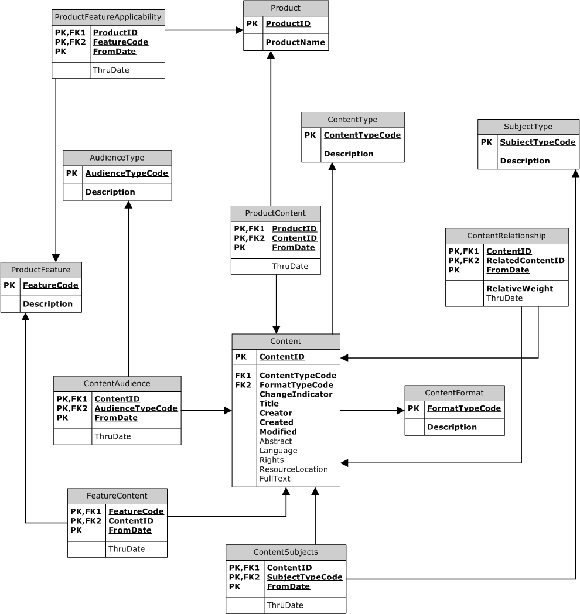

Figure 1: E-R Diagram of the Modified Data Model

Conclusion

The addition of the above-mentioned elements from the Dublin Core allows the content of a website to be catalogued, categorized, and managed more easily. The date fields make it easy to automate the scheduled delivery of digital content, and many of the other metadata items make it easy to track revisions and empower content creators, contributors, editors, publishers, and consumers. This information is critical for developing robust content management solutions and much of it was notably absent from the core Universal Data Model. This is to be expected, of course, since the UDM was conceived as a generalized, multi-purpose database. Yet it remains this author’s contention that every organization that needs to maintain digital content (descriptions or images) about its products, services, or even personnel can benefit from the addition of standard metadata items into their data stores.

References

[DCMI] DCMI Usage Board. DCMI Metadata Terms. Web resource location: http://www.dublincore.org/documents/dcmi-terms/ March, 4 2003.

[UDM] Silverston, Len. The Data Model Resource Book, Vol. 1: A Library of Universal Data Models for All Enterprises. John Wiley & Sons. 2001.

[UDM2] Silverston, Len. The Data Model Resource Book, Vol. 2: A Library of Universal Data Models by Industry Types. John Wiley & Sons. 2001.

